

Student Name……………………………………

FURTHER MATHEMATICS

TRIAL EXAMINATION 1

2015

Reading Time: 15 minutes
Writing time: 1 hour 30 minutes

Instructions to students
This exam consists of Section A and Section B.
Section A contains 13 multiple-choice questions from the core, 'Data Analysis'.
Section A is compulsory and is worth 13 marks.
Section B consists of 6 modules each containing 9 multiple-choice questions. You should choose 3 of these modules and answer every question in each of your chosen modules.
Each of the modules is worth 9 marks.
Section B begins on page 9 of this exam.
There is a total of 40 marks available for this exam.
Unless otherwise stated the diagrams in this exam are not drawn to scale.
Students may bring one bound reference into the exam.
Students may bring into the exam one approved graphics calculator or approved CAS calculator or CAS software and, if desired, one scientific calculator. Calculator memory does not need to be cleared.
An answer sheet appears on page 34 of this exam.
Formula sheets can be found on pages 32 and 33 of this exam.

This paper has been prepared independently of the Victorian Curriculum and Assessment Authority to provide additional exam preparation for students. Although references have been reproduced with permission of the Victorian Curriculum and Assessment Authority, the publication is in no way connected with or endorsed by the Victorian Curriculum and Assessment Authority.

© THE HEFFERNAN GROUP 2015
This Trial Exam is licensed on a non transferable basis to the purchasing school. It may be copied by the school which has purchased it. This license does not permit distribution or copying of this Trial Exam by any other party.
SECTION A

CORE – Data Analysis

This section is compulsory.

Question 1

The ordered stemplot below shows the percentage of left handed students in each of the 20 classes at a school.

Key: 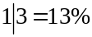

0 | 4
0 | 8 | 8 | 9
1 | 1 | 1 | 3
1 | 6 | 6 | 6 | 7 | 8
2 | 0 | 1 | 3 | 3 | 4
2 | 7 | 8 | 9
3

The number of classes at this school with less than 10% of left handed students is

- 1
- 2
- 3
- 4
- 5

Question 2

The types of cars used by people can be classified as sedan, utility or wagon. The frequency table below shows the types of cars used by a group of 245 people at their work and at home.

 |  | Work
 |  | sedan | utility | wagon
Home | sedan | 42 | 32 | 25
Home | utility | 19 | 22 | 16
Home | wagon | 23 | 39 | 27

The number of people whose work car is classified as a wagon is

- 25
- 27
- 68
- 89
- 93

Question 3

The weight of a large group of 18 year old boys is approximately normally distributed with a mean of 75kg and a standard deviation of 6kg.
If 870 boys in this group are randomly selected, the number expected to weigh between 63kg and 87kg is closest to

- 435
- 592
- 709
- 827
- 867

Use the following information to answer Questions 4 and 5.

The segmented bar chart below shows the age distribution of people living in three types of housing (house, ground-level unit and high-rise apartment) in a city in 2012.
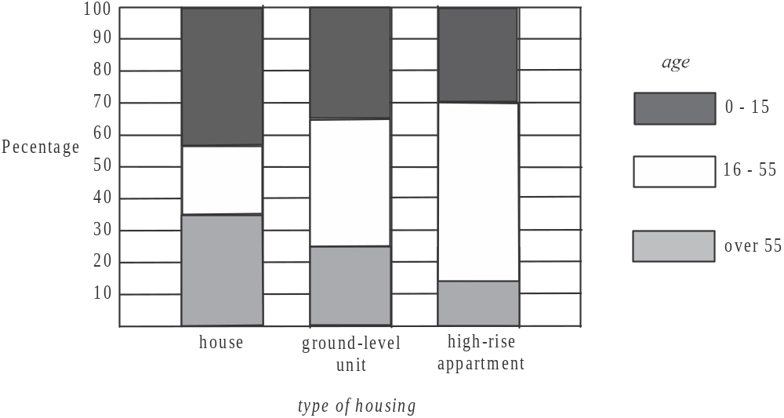

Question 4

The percentage of people living in a high-rise apartment in this city who were aged 16 – 55 in 2012 was closest to

- 15%
- 30%
- 40%
- 55%
- 70%

Question 5

The variables age (0-15, 16-55, over 55) and type of housing (house, ground-level unit, high-rise apartment) are

- both numerical
- both categorical
- neither numerical or categorical
- numerical and categorical respectively
- categorical and numerical respectively.

Question 6

The parallel box-plots below show the distribution of the number of hits, per day, on a website during the months of January and February.
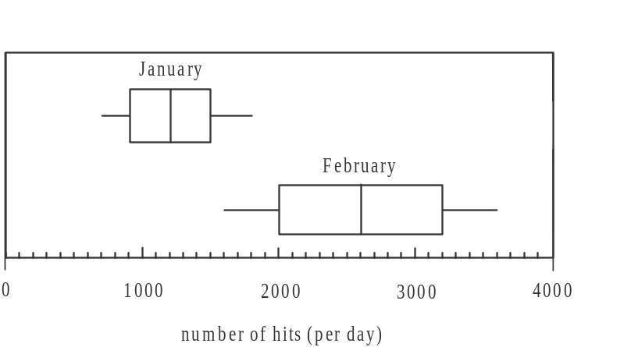

Which one of the statements below is true?

- On more than 75% of days in January the website had less hits than on any day in February.
- The median number of hits to the website in February was approximately 1200.
- The number of hits to the website was less variable in February than in January.
- The number of hits to the website was, on average, higher in January than in February.
- On half the days in February there were between 2000 and 3000 hits to the website.
Question 7

The data in the scatterplot below has a least squares regression line fitted to it.
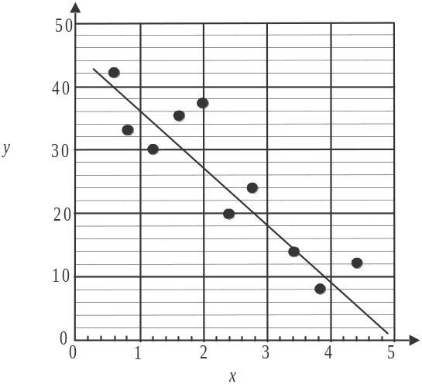

The residual plot which corresponds to this is closest to
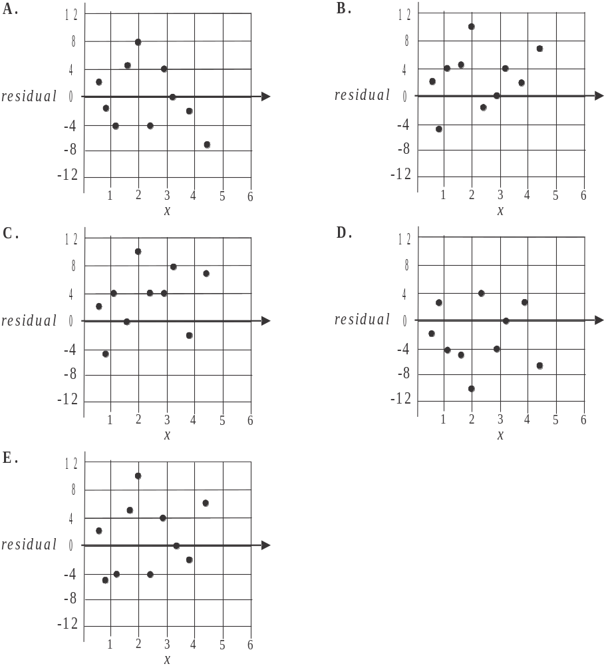

Use the following information to answer Questions 8 and 9.

The table below shows the number of students who tried out for 11 different senior school teams at a school in 2004 and in 2014.

Team | Number of Students
Team | 2004 | 2014
cricket | 38 | 24
debating | 16 | 12
netball | 28 | 24
soccer | 19 | 33
chess | 8 | 7
tennis | 15 | 12
diving | 5 | 3
public speaking | 11 | 8
athletics | 48 | 41
hockey | 33 | 29
cross-country | 29 | 22

Question 8

The value of r, Pearson’s correlation coefficient, for this data is closest to

- 0.76
- 0.77
- 0.87
- 0.93
- 0.98

Question 9

The number of students who tried out in 2014 is taken as the dependent variable and the number of students who tried out in 2004 is taken as the independent variable.
From the data in the table, it can be concluded that the percentage of the variation in the number of students who tried out in 2014 that is explained by the variation in the number of students who tried out in 2004 is closest to

- 76%
- 77%
- 87%
- 93%
- 98%

Question 10

The table below displays the average monthly maximum temperature (in °C) in an outback region over a year.

Month | Jan | Feb | Mar | Apr | May | Jun | Jul | Aug | Sep | Oct | Nov | Dec
Temperature | 38 | 39 | 31 | 27 | 22 | 17 | 16 | 22 | 28 | 31 | 33 | 35

Using three mean moving average smoothing, the smoothed value for the average monthly maximum temperature in September is

- 26
- 27
- 28
- 29
- 30

Question 11

The time series plot below displays the number of orders a business received each month during 2013.
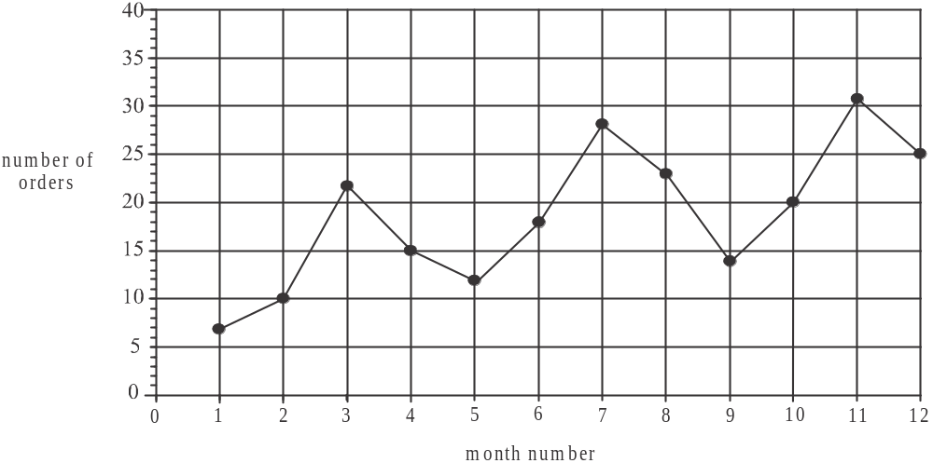

A trend line is fitted to this data using the three median method.
The slope of this three median trend line would be closest to

- – 1.5
- – 1.2
- 0.5
- 1.2
- 1.5
Question 12

The turnover in dollars each quarter for a business in its first year of operation is shown below.

Quarter | Turnover ($)
1 | 42 500
2 | 63 900
3 | 110 500
4 | 138 600

This information is used to determine the seasonal index for each quarter.
The seasonal index for Quarter 3 will be closest to

- 0.44
- 0.48
- 0.72
- 1.24
- 1.56

Question 13

A set of deseasonalised quarterly revenue data for 2014 is produced and a trend line is fitted to it.
The equation of the trend line is

The seasonal indices for all but quarter 2 are shown in the table below.

Quarter number | 1 | 2 | 3 | 4
Seasonal index | 0.9 |  | 1.4 | 0.6

According to the trend line, the actual revenue for quarter 2 in 2014 is predicted to be closest to

- $628 135
- $652 600
- $717 860
- $751 000
- $783 120

SECTION B

Module 1: Number patterns

If you choose this module all questions must be answered.

Question 1

In the first week of term Kristen did 30 minutes of homework each night. In the second week she did 50 minutes each night and in the third week she did 70 minutes each night. If Kristen continues this pattern, the number of minutes of homework she will do each night in week 10 of term will be

- 190
- 210
- 230
- 270
- 290

Question 2

In 2015 there were 15 000 residents in a new housing estate. The number of residents is forecast to increase by 7% each year.
The forecast for the number of residents in the new housing estate in 2020 is closest to

- 20 000
- 21 000
- 22 500
- 210 000
- 350 000

Question 3

Les has a load of topsoil delivered in his driveway.
The amount of topsoil, in cubic metres, that he is able to move from his driveway in successive hours, is given by the geometric sequence
0.4, 0.2, 0.1, …
The amount of topsoil, in cubic metres, that Les had delivered in his driveway was

- 0.7
- 0.75
- 0.8
- 0.95
- 1.0

Question 4

At Bert’s first training session he does 5 push-ups. At each subsequent training session he increases the number of push-ups he does by 3.
Let 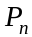 be the number of push-ups Bert does at his n^{th} training session.
A difference equation that can be used to model this situation is

- 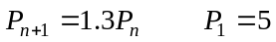
- 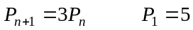
- 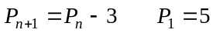
- 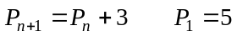
- 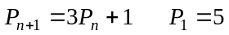

Question 5

For the difference equation the sixth term is 35.
The value of b is

- 1
- 2
- 3
- 4
- 5

Question 6

The sequence 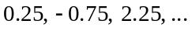 can be generated by the difference equation given by

- 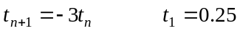
- 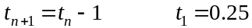
- 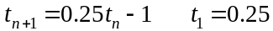
- 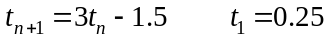
- 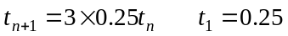

Question 7

A sequence is generated by the difference equation 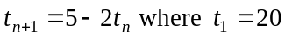.
This sequence is

- arithmetic
- increasing
- geometric
- decreasing
- neither arithmetic nor geometric

Question 8

A supermarket has 3 420 discounted Easter eggs to be sold.
The number of these eggs sold in the first three hours that they go on sale is shown in the table below.

hour | 1 | 2 | 3
number of Easter eggs sold | 120 | 150 | 180

This pattern of selling continues until all the discounted Easter eggs are sold.
The number of hours it takes to sell all the discounted Easter eggs is

- 5
- 7
- 9
- 11
- 12

Question 9

A new green waste management facility opens and at the start of each week it receives on site 30 tonnes of waste. Each week 80% of the waste is processed leaving 20% remaining on site.
Let 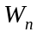 be the number of tonnes of waste the facility has on site at the start of the n^{th} week of being open.

The difference equation that is used to find the number of tonnes of waste on site at the start of the n^{th} week of being open is

.

Which one of the following statements is not true?

- At the start of the 3rd week of being open there is more than 37 tonnes of waste on site.
- The amount of waste processed at the facility changes each week.
- If no waste were received at the start of the 5th week of being open, there would be less than 7.5 tonnes of waste on site.
- The amount of waste processed each week is always less than 24 tonnes.
- The amount of waste on site never exceeds 37.5 tonnes.

Module 2: Geometry and trigonometry

If you choose this module all questions must be answered.

Question 1

A metal brace of length 18 cm supports a horizontal shelf and makes an angle of 35 with it as shown in the diagram below.
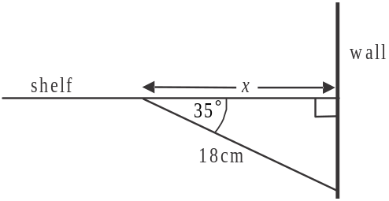

The distance x, from the wall to where the brace is attached to the shelf, is closest to

- 10.3cm
- 12.6cm
- 14.7cm
- 22.0cm
- 31.4cm

Question 2

On a map, the distance between two towns is 5cm. The actual distance between the towns is 2.4km. The scale on the map is

- 1:1 200
- 1:4 800
- 1:12 000
- 1:48 000
- 1:120 000

Question 3

The position of two mines M and N are shown in the diagram below.
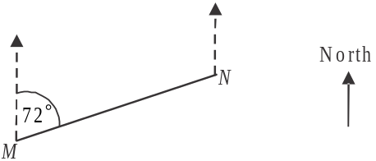

The bearing of mine N from mine M is 072.
The bearing of mine M from mine N is

- 072
- 108
- 162
- 188
- 252

Question 4

On the contour map below the contour intervals are 20m.

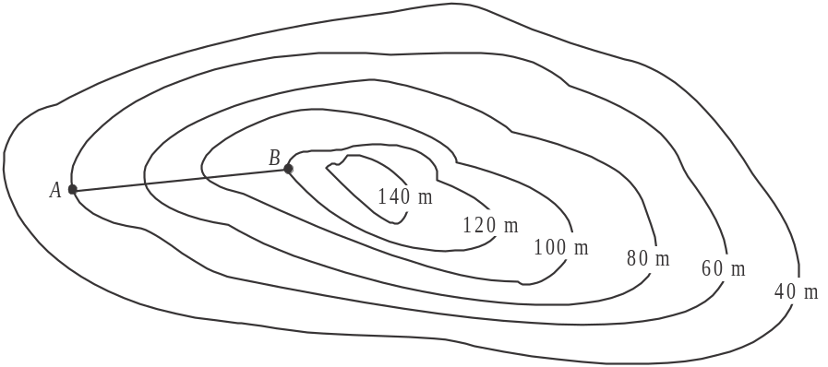

The horizontal distance between point A and point B is 1 200m.
The average slope between point A and point B is

- 0.05
- 0.2
- 0.5
- 20
- 50

Question 5

Regular hexagonal tiles with a side length of 2cm are used to tile a bathroom as shown in the diagram below.
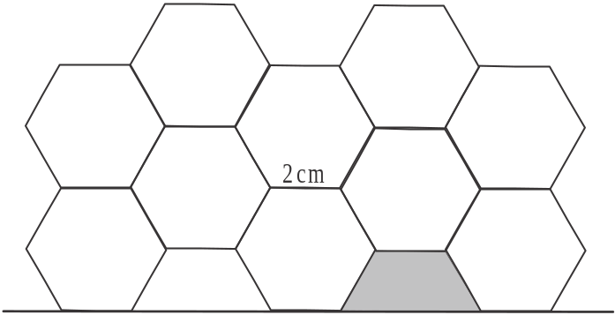

The area, in cm, of the shaded half tile is closest to

- 1.3
- 1.7
- 5.2
- 8.1
- 10.4
Use the following information to answer Questions 6 and 7.

Four bollards are placed at the edges of a footpath, which is shaded below, at points A, B, D and E and a fifth is placed off the footpath at point C as shown in the diagram below.
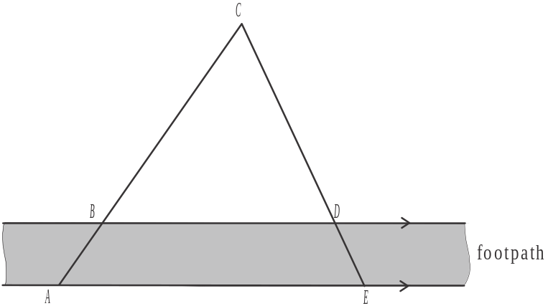

Fluorescent tape joins each of the bollards to form a large triangle ACE. The edges of the footpath are parallel and the distance BD is 2m. The distance AB is 1.2m and the distance BC is 3m.

Question 6

The length of fluorescent tape, in metres, running along the edge of the footpath, from point A to point E is

- 2.1
- 2.8
- 3.0
- 3.5
- 5.0

Question 7

If the distance CD is 2.5m, then the area enclosed by triangle BCD, in square metres, can be found by calculating

- 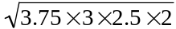
- 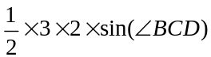
- 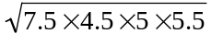
- 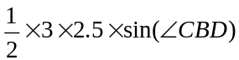
- 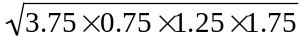

Question 8

Along a straight section of freeway that runs in an east-west direction, there is an exit point E. A straight road of length 450m runs from point E to a rest area at point A.
The bearing of point A from point E is 055.
A second straight road runs from point A back to meet the freeway at point R, which is due east of point E.
The bearing of point A from point R is 290.
The length in metres, of this second straight road from point A to point R is closest to

- 268
- 422
- 755
- 839
- 2 294

Question 9

A cake stand in the shape of a square pyramid has three tiers and comes with a light fabric covering to keep insects away.
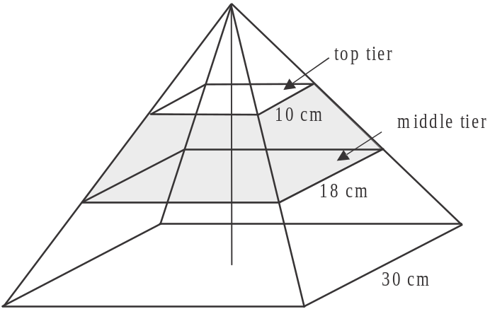

The horizontal side lengths of the respective tiers are 10cm, 18cm and 30cm.
When the fabric covering is on, the enclosed volume of the top tier is 500cm. The enclosed volume in cm of the middle tier, which is shaded in the diagram, is

- 900
- 1 120
- 1 620
- 2 416
- 2 916

Module 3: Graphs and relations

If you choose this module all questions must be answered.

Question 1

The horizontal line that passes through the point 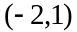 has the equation given by

- 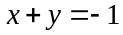
- 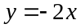
- 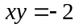
- 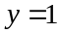

Question 2

The internal temperature, in degrees Celsius, of a machine operating over a ten hour period is shown in the graph below.

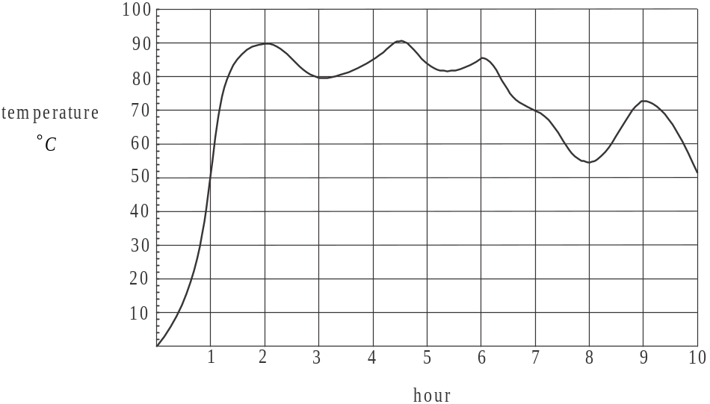

The percentage of this ten hour period during which the machine was operating at above 50C was

- 10%
- 40%
- 50%
- 90%
- 100%

Question 3

A group of cyclists start a ride at 8am, finish it at 2pm and have a total of 2 hours of rest in between. The distance-time graph below shows their trip.
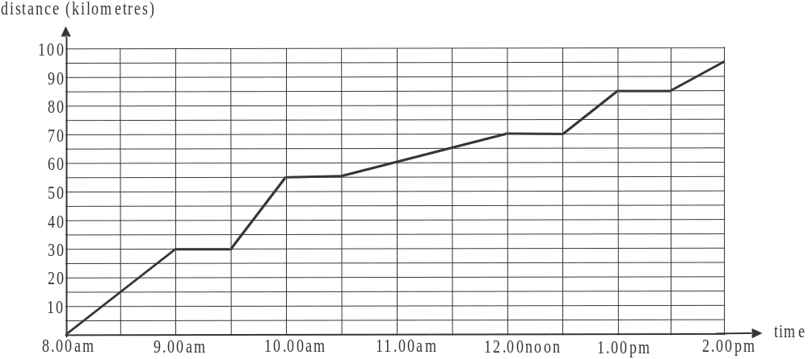

The speed in kilometres per hour, of the group is greatest between

- 8.00am and 9.00am
- 9.30am and 10.00am
- 10.30am and 12 noon
- 12.30pm and 1.00pm
- 1.30pm and 2.00pm

Question 4

The recommended amount of fertilizer, in grams, to be applied to young trees according to their age, is shown on the step graph below.
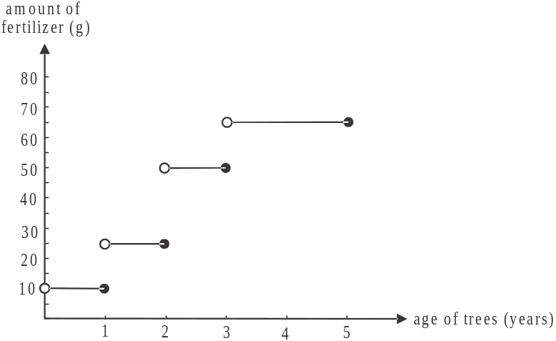

Maureen used a total of 75 grams of fertilizer to fertilize two of her young trees according to the recommendations.
The age in years of her two young trees could be
- one year and two years
- one year and three years
- two years and three years
- two years and four years
- three years and four years

Question 5

The cost of a pedicure at a beauty salon is twice the cost of a manicure.
Jude pays a total of $152 for a manicure for herself as well as a manicure and pedicure for her daughter.
The cost of a pedicure at this beauty salon is

- $19.00
- $30.40
- $38.00
- $60.80
- $76.00

Question 6
A graph of y versus 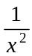 is shown on the graph below.
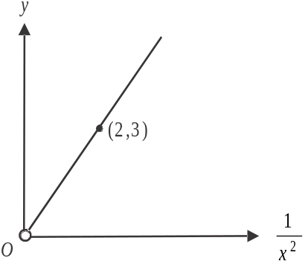

The rule that relates x and y is
- 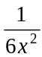
- 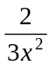
- 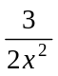
- 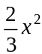
- 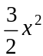

Question 7
Sandra works at a hospital and at a private clinic.
Let x be the number of hours she works at the hospital each week.
Let y be the number of hours she works at the private clinic each week.
Sandra’s hourly rate at the hospital is $35 and at the private clinic it is $42.
Sandra must work at least as many hours at the hospital as at the private clinic and she needs to earn at least $1600 per week from these two jobs.
These constraints can be represented by the inequalities

- 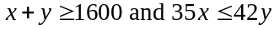
- 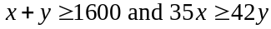
- 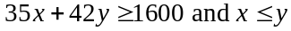
- 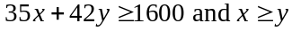
- 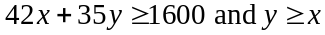
Question 8

A linear programming problem has constraints given by the following set of inequalities.
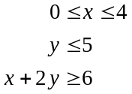
The corner points of the feasible region for this problem have the coordinates given by

- 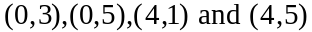
- 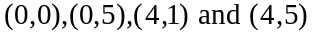
- 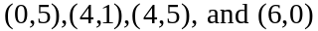
- 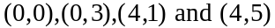
- 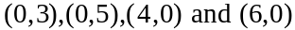

Question 9

The feasible region (indicated by the shaded area) for a linear programming problem, together with the equations of the lines that define the boundaries of that region, are shown below.

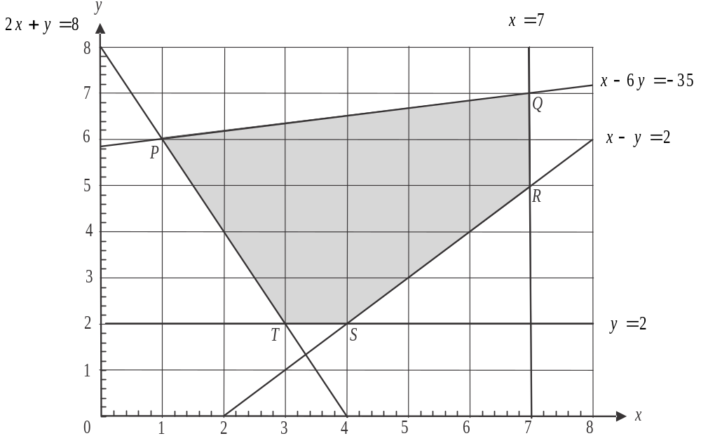

Points, P, Q, R, S and T are the corner points of the feasible region.
The objective function C has its minimum value at any point along the line that joins point P and point T.
The function C could have the rule given by

- 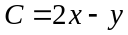
- 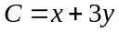
- 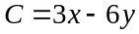
- 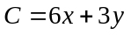
- 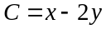
Module 4: Business-related mathematics

If you choose this module all questions must be answered.

Question 1

A suitcase that usually sells for $160.00 is discounted by 40%. The discounted price of the suitcase is

- $40.00
- $64.00
- $88.00
- $96.00
- $120.00

Question 2

$12 000 is invested for 3 years and the total amount of simple interest earned during that time is $1 044. The interest rate per annum on this investment was

- 2.9%
- 4.1%
- 8.7%
- 10.44%
- 26.1%

Question 3

At a green grocer’s, the cost of 1kg of tomatoes on Wednesday was $4.
The cost of 1kg of tomatoes on Thursday was 10% less than the cost on Wednesday.
The cost of 1kg of tomatoes on Friday was 20% more than the cost on Thursday.
The cost of 1kg of tomatoes on Friday can be found by calculating

- 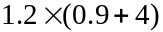
- 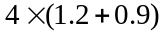
- 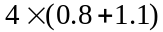

Question 4

A landscape gardener quotes a price of $935 for a job. This amount includes his charge plus a Goods and Services Tax (GST) of 10%. The amount of GST included in this price is

- $9.35
- $78.50
- $85.00
- $93.50
- $135.00

Question 5
A commercial dryer is depreciated by $0.38 for each load that it dries. The dryer was purchased for $9 500 four years ago. Its depreciated value now is $4 940.
The total number of loads it has dried in the last four years is

- 12 000
- 13 000
- 19 000
- 23 000
- 25 000

Question 6
Sue buys a bedroom suite for $3 200. She is to make monthly payments of $140 for two years. The effective rate of interest per annum that she is charged is

- 2.5%
- 2.9%
- 3.2%
- 4.8%
- 5.0%

Question 7
Amanda invested $2 400 for 4 years. Interest was compounded weekly and at the end of 4 years the value of her investment was $2 805.02.
The annual interest rate on this investment was closest to

- 0.3%
- 3.9%
- 5.8%
- 15.6%
- 15.9%

Question 8
Rana purchases an annuity for $40 000 which is invested at 5.2% interest per annum compounding quarterly. Rana receives quarterly payments of $3 500 from this investment.
The number of years that Rana will receive these payments is closest to

- 2.7
- 3.1
- 6.8
- 10.7
- 12.4

Question 9
Vesna takes out a home loan with a bank which charges 7.2% interest per annum. She makes repayments of $1 300 each week for 250 weeks and then makes a final payment of $627.54 which sees the loan fully repaid.
The amount that Vesna borrowed from the bank originally was

- $274 000
- $274 556
- $275 000
- $275 458
- $276 000
Module 5: Networks and decision mathematics

If you choose this module all questions must be answered.

Question 1

The least number of edges that need to be added to the graph shown below to make it a connected graph is

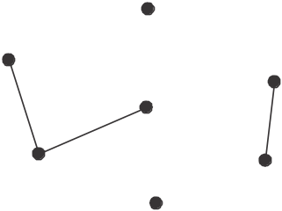

- 2
- 3
- 4
- 10
- 12

Question 2
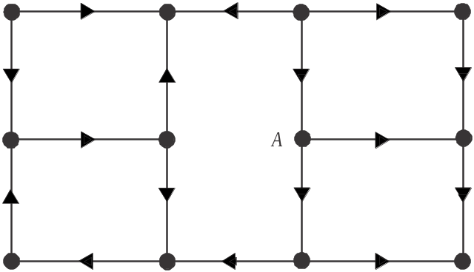

For the directed graph shown above, the number of vertices that are reachable from vertex A is

- 2
- 7
- 8
- 9
- 11

Question 3

The vertices of the graph shown below represent ten newly planted trees. The edges represent the distances, in metres, between the trees where pipes for a watering system are to be laid.

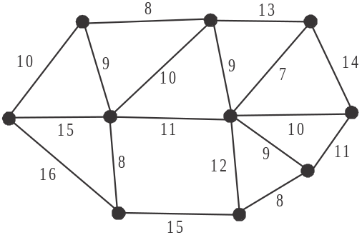

Using the same set of edges and vertices, which one of the following graphs shows the pipe layout for the watering system that would link all the trees but use a minimum length of pipe?

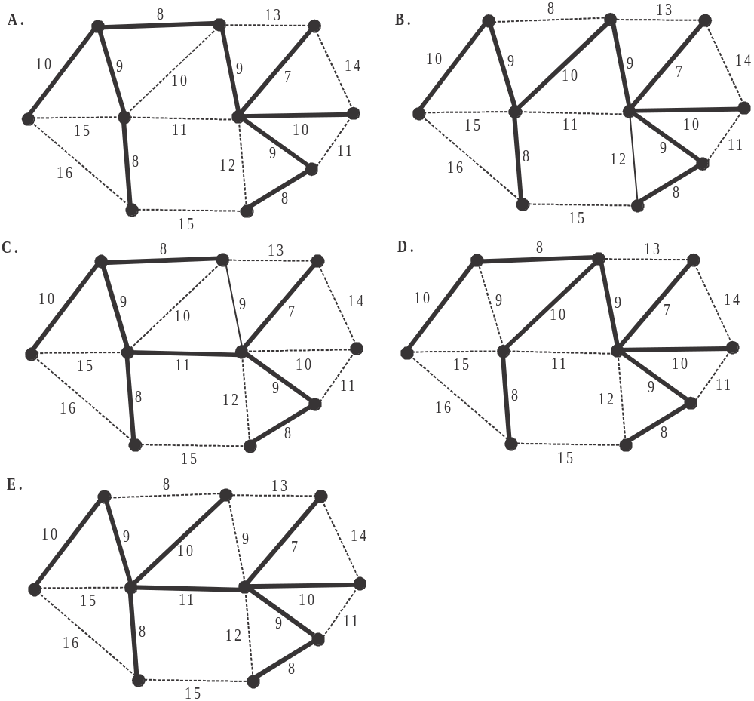

Question 4

A graph is to be drawn from the adjacency matrix below.

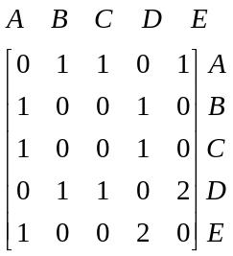
Which one of the following statements about the graph is not true?

- The graph will have 5 vertices.
- The graph will be planar.
- The graph will have no isolated vertices.
- The graph will have 14 edges.
- The graph will have no loops.
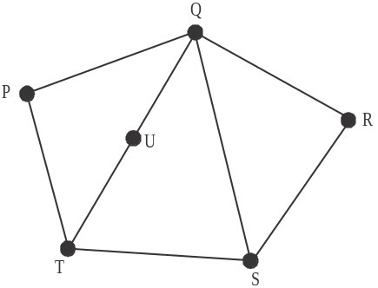

Question 5

Which one of the following statements is not true for the graph shown above?

- The graph contains an Euler path.
- The graph is planar.
- The graph contains a Hamiltonian path.
- The sum of the degrees of the vertices is 16.
- The graph contains a Hamiltonian circuit.

Question 6

A graph is connected and has 4 vertices and 3 edges.
Consider the following four statements.
- The graph has one face.
- The graph is planar.
- The graph can have multiple edges between two vertices.
- All the vertices of the graph can have an odd degree.

The number of these statements which are true for this graph is

- 0
- 1
- 2
- 3
- 4

Question 7

The results of a soccer tournament conducted with five teams, Aces, Blues, Cats, Dynamos and Excels are shown on the directed graph below.

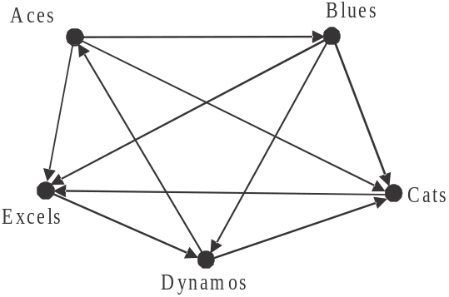

The direction of the arrow indicates the winner of the game so, for example, the arrow from the Aces to the Blues indicates that the Aces defeated the Blues.
In order to rank the teams, the sum of the one-step and two-step dominances of each team is calculated to produce a dominance score.
From highest to lowest, the ranking of the teams is given by

- Aces, Blues, Dynamos, Cats, Excels
- Aces, Blues, Dynamos, Excels, Cats
- Aces, Dynamos, Blues, Excels, Cats
- Blues, Aces, Dynamos, Cats, Excels
- Blues, Aces, Cats, Dynamos, Excels
Question 8

The 12 tasks, A – L, required to complete a project together with the duration of each task, in days, as well as any immediate predecessors of the tasks are shown in the table below.

Task | Duration (days) | Immediate predecessor(s)
A | 2 | -
B | 4 | -
C | 5 | A
D | 3 | B
E | 6 | A
F | 2 | C, D
G | 7 | B
H | 5 | E
I | 3 | E, F, J
J | 4 | G
K | 7 | G
L | 3 | H

The network which represents this information is

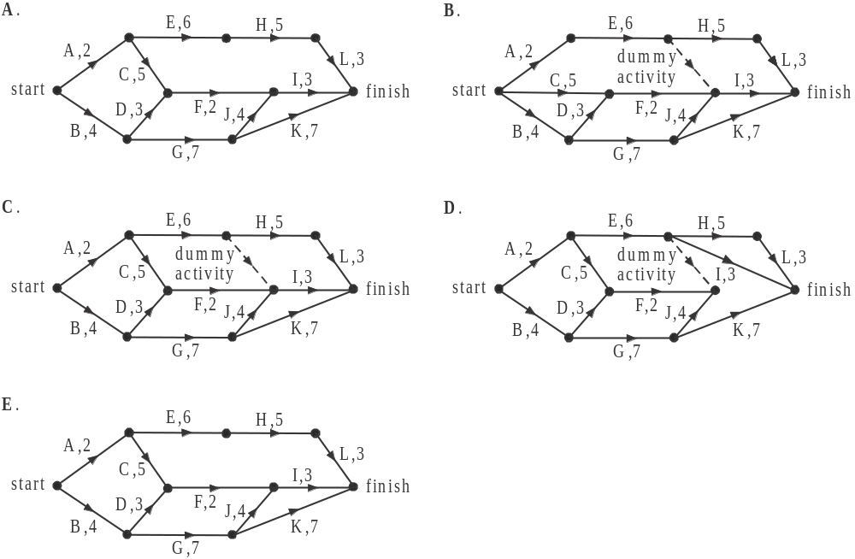

Question 9

A network of pipes connects two inlet drains to an outlet drain as shown in the directed graph below.
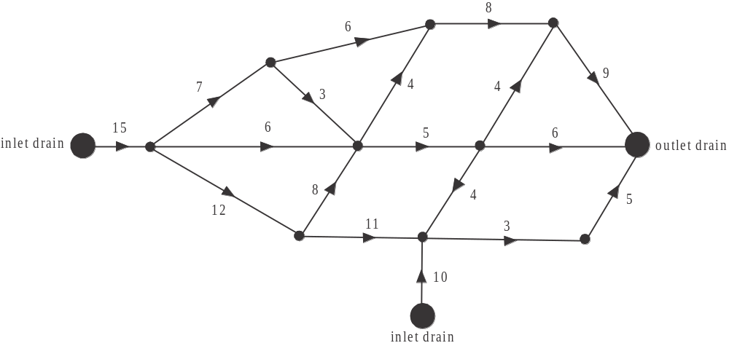

The direction in which the water flows is indicated by the arrows and the capacity of each pipe, in litres per hour, is indicated by the numbers.

The maximum capacity of the system in litres per hour, reaching the outlet drain is

- 10
- 15
- 16
- 17
- 25
Module 6: Matrices

If you choose this module all questions must be answered.

Question 1

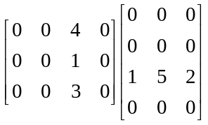
is equal to

- 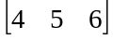
- 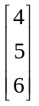
- 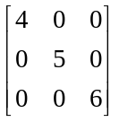
- 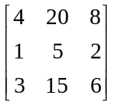
- 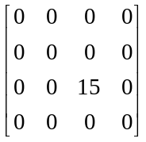

Question 2

Let 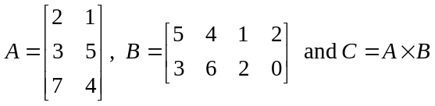.

The element in the second row and third column of matrix C can be found by calculating

Question 3

Given that the determinant of 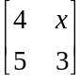 is equal to 2, then the value of x is

- – 3
- – 2
- 2
- 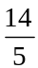

Question 4

The matrix equations I – IV below, each represent a system of simultaneous linear equations.

I 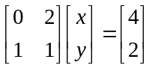 II 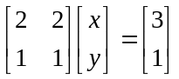
III 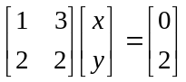 IV 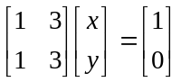
The system(s) that have a unique solution are represented by matrix equation(s)

- I only
- II only
- I and III only
- II and IV only
- III and IV only

Question 5

A butcher has 240 customers who pay their account each month. In January 80 paid in cash (C), 80 paid using a credit card (CC) and 80 paid using a debit card (DC).
It is expected that this group of customers will change the way they pay their account from month to month according to the transition matrix T below.

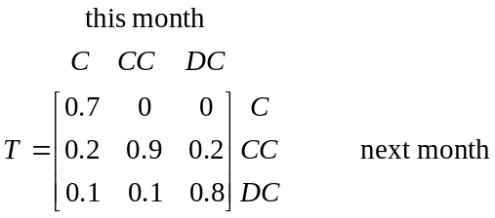

Over the long term, the number of these customers expected to pay using credit card is closest to
- 0
- 80
- 160
- 200
- 240

Question 6

A shoe business operates four retail outlets. During the end of year sales it sells its men’s shoes for $60, its women’s shoes for $50 and its children’s shoes for $30. The number of shoes sold at each of the four retail outlets during this sale is shown in the table below.

Retail outlet | Men’s | Women’s | Children’s
City | 289 | 179 | 68
Eastside | 172 | 213 | 207
Westside | 139 | 243 | 262
Northside | 240 | 211 | 223

A matrix product that produces a matrix showing the amount in dollars spent at each retail outlet during the sale is

- 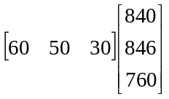
- 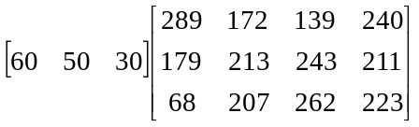
- 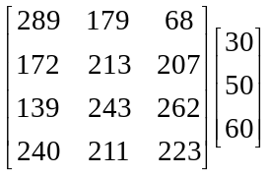
- 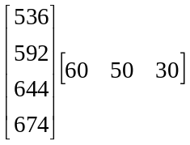
- 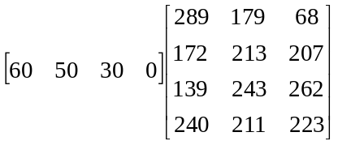

Question 7

Craig goes to the gym each weekday. At each of his visits, he does one of the five optional sessions; weights (W), aerobics (A), pump (P), yoga (Y) or spin (S). At the end of each week he will have attended each session once. The matrix below shows which session he will do on the next day, for each of the sessions he attends.

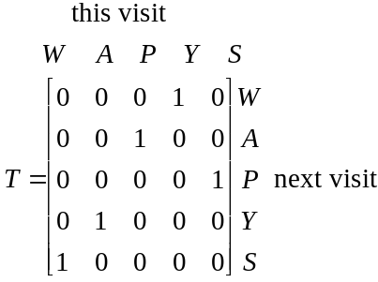

Last Wednesday Craig did a weights session.
The order in which Craig attends each of the sessions from Monday to Friday is

- spin, pump, weights, aerobics, yoga
- aerobics, yoga, weights, spin, pump
- pump, spin, weights, aerobics, yoga
- yoga, aerobics, weights, spin, pump
- aerobics, yoga, weights, pump, spin

Question 8
For the matrix equation 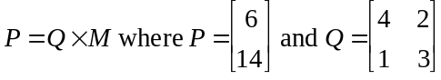, the matrix M is given by
- 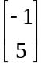
- 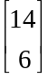
- 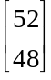
- 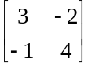
- 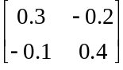

Question 9

The matrix products are both defined where I is a particular identity matrix.
The statement which is not true is

- The product is always defined.
- I must be a square matrix.
- B could be a column matrix.
- B must be a square matrix.
- The sum of could exist.
Further Mathematics Formulas

Core: Data analysis

standardised score: 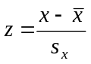
least squares line: 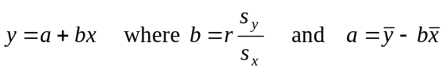
residual value: residual value = actual value – predicted value

seasonal index: seasonal index 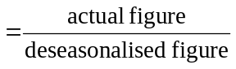

Module 1: Number patterns

arithmetic series: 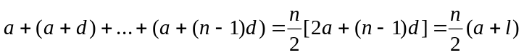
geometric series: 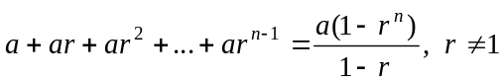
infinite geometric series: 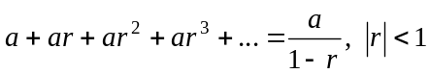

Module 2: Geometry and trigonometry

area of a triangle: 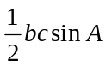
Heron's formula: 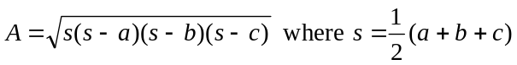
circumference of a circle: 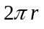

area of a circle: 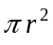

volume of a sphere: 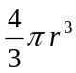
surface area of a sphere: 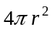

volume of a cone: 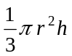
volume of a cylinder: 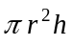

volume of a prism: 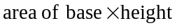
volume of a pyramid: 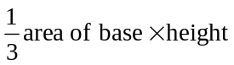

Mathematics Formula Sheets reproduced by permission; © VCAA 2014. The VCAA does not endorse or make any warranties regarding this study resource. Current and past VCAA VCE® exams and related content can be accessed directly at www.vcaa.vic.edu.au
Pythagoras’ theorem 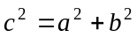

sine rule: 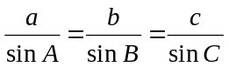
cosine rule: 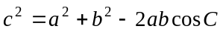

Module 3: Graphs and relations

Straight line graphs
gradient (slope): 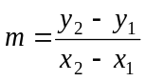
equation: 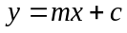

Module 4: Business-related mathematics

simple interest: 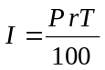
compound interest: 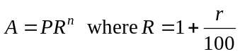
hire purchase: 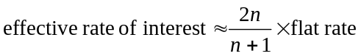

Module 5: Networks and decision mathematics

Euler’s formula: 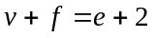

Module 6: Matrices

determinant of a 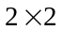 matrix 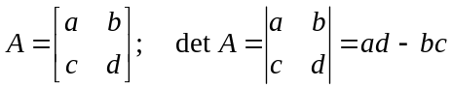
inverse of a matrix 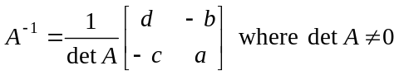

END OF FORMULA SHEET

